2019 NYTI Process

- Get the Parameter files from PROD environments.
- Generally, 3 parameter files used for NYTI Run.
- Parameter Files should place the /AMSROOT/RTFiles/FINSYS/Parms:
Note: Since this process has run for FY2019 New year parameter value is 2019 and base year parameter is previous year 2018
- Before running the job, the parameter should update the NYTI job to every parameter un.
- Page Search for code BAT* and then click on Job Setup.
- Expand Financial -> Utilities- > Chain Job- > NYTI Process - > NYTI Process
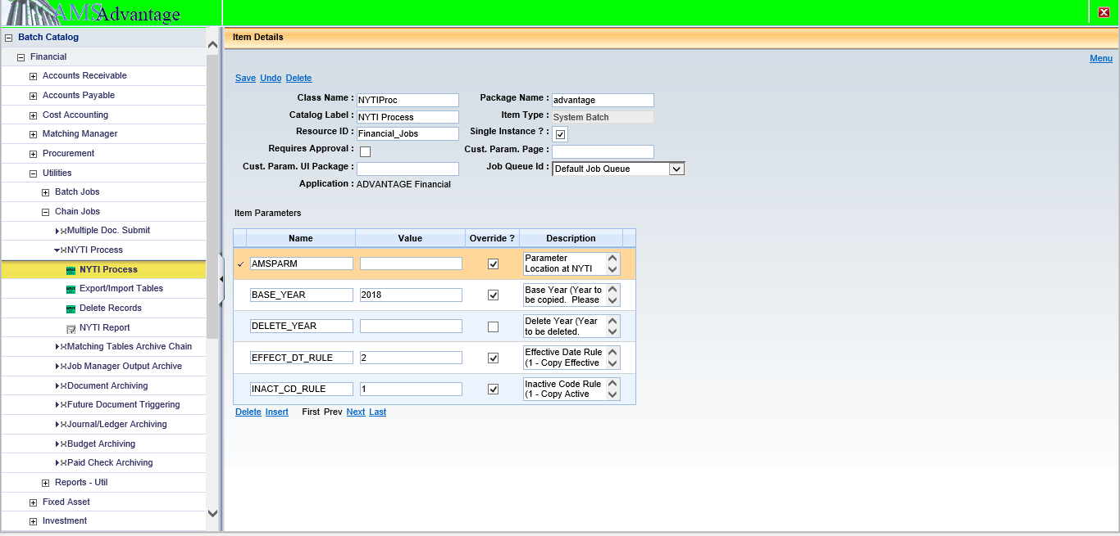

- We have changed value of PARM_FILE.
  - Old value: NYTI_TABLE_PARM_GN_FUND_CNST_PRD2019.txt
  - New Value: NYTI_TABLE_PARM_GN_FUND_CNST.txt
Earlier with old value for PARM_FILE, No NYTI process getting success.
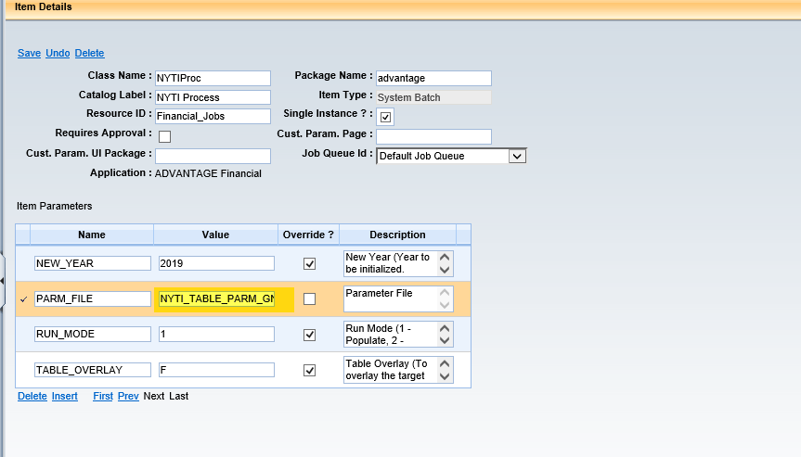
- Run job with parameter file NYTI_TABLE_PARM_SYS.txt.
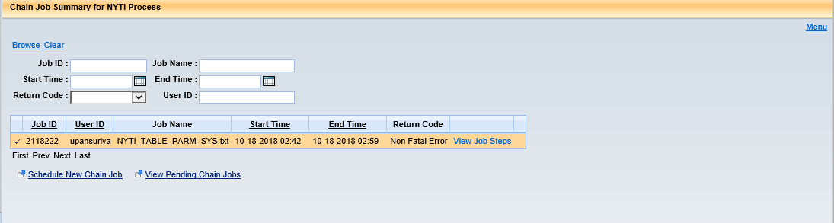

- We are considering Job as successful job, If we are getting Successful status for NYTI Process catlog Name.
- In below screenshot, we are checking status of 1st row.

